|  |  |
| --- | --- |
| **Test Name** | Crown & Anchor Automated Test Bug 2 |
| **Use Case Tested:** | Automate the testing of errors in UAT Test 2 (for Bug 2) |
| **Test Description:** | Test that player cannot reach betting limit |
| **Pre-conditions** | Single player ‘Richard’ created  Game limit is set = 0  Each run to use a single dice value ‘CROWN’ as the player’s pick  Game will play 10 turns |
| **Post-conditions** | n/a |
| **Notes:** | **An assert will determine if player’s balance reaches the zero limit.**  **This test also shows Bug 4, which is that each roll in the same game produces the same three dice rolls.** |
| **Result (Pass/Fail/Warning/Incomplete)** | **1) Fail: Player keeps losing and limit reached (exception error displayed) but balance = 5 (still above limit of zero). Note that test fails because exception is picked up by module before assert is invoked.**  **2) Pass: Player kept winning on one matched die, so balance was not zero by the end of 10 turns.**  **3) Pass: Player kept winning on two matched dice, so balance was not zero by the end of 10 turns.** |

# Screenshots for Results (by number of result)

1) Player keeps losing and limit reached but balance is above limit:

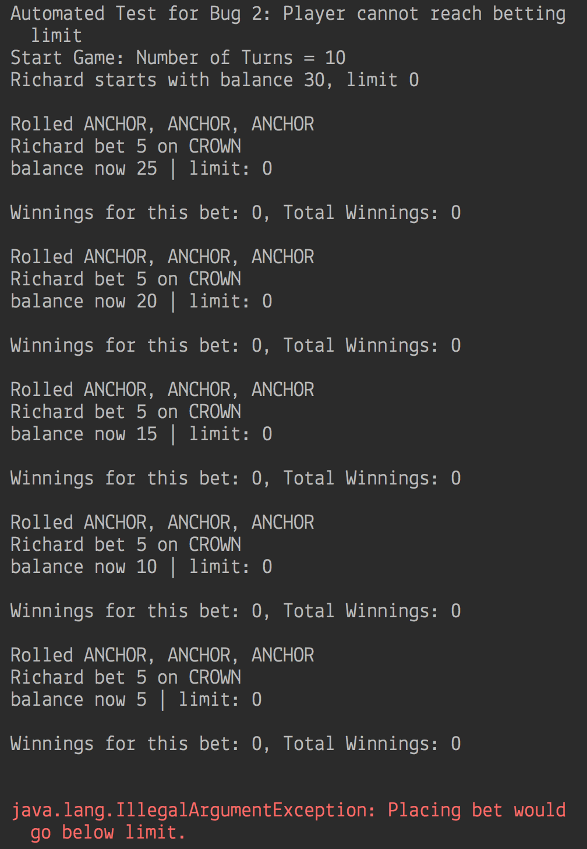

2) Player keeps winning on one match but balance unchanged (never reaches limit):

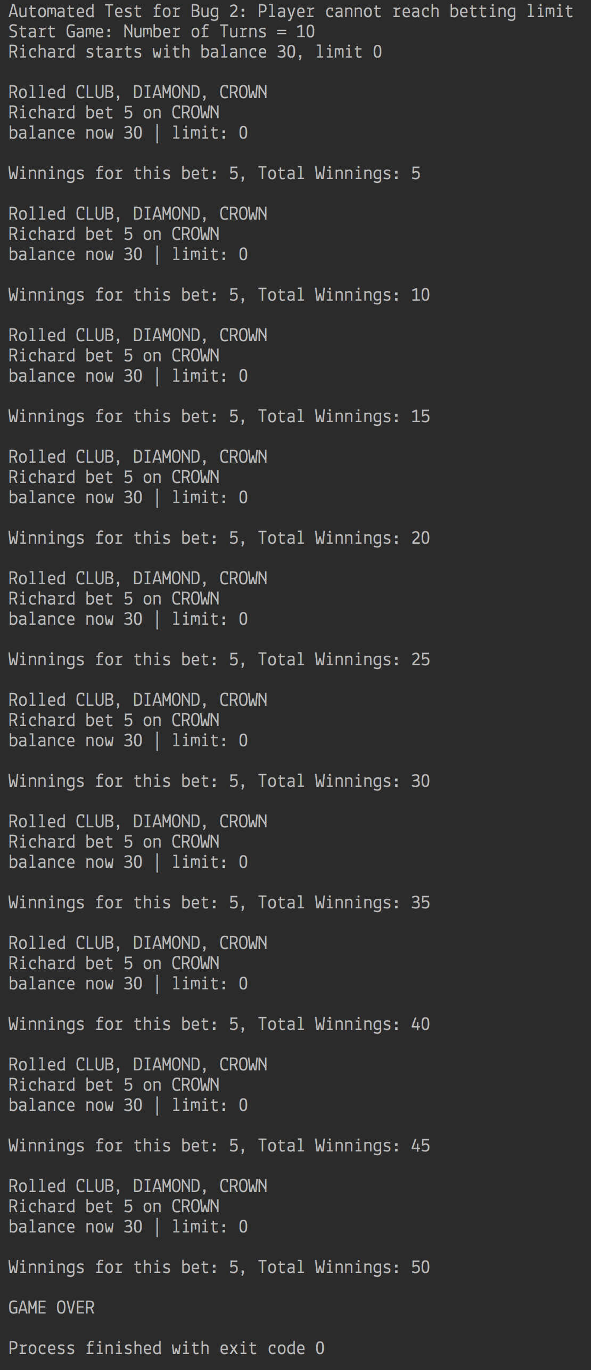

3) Player keeps winning on two matches but balance unchanged (never reaches limit):

